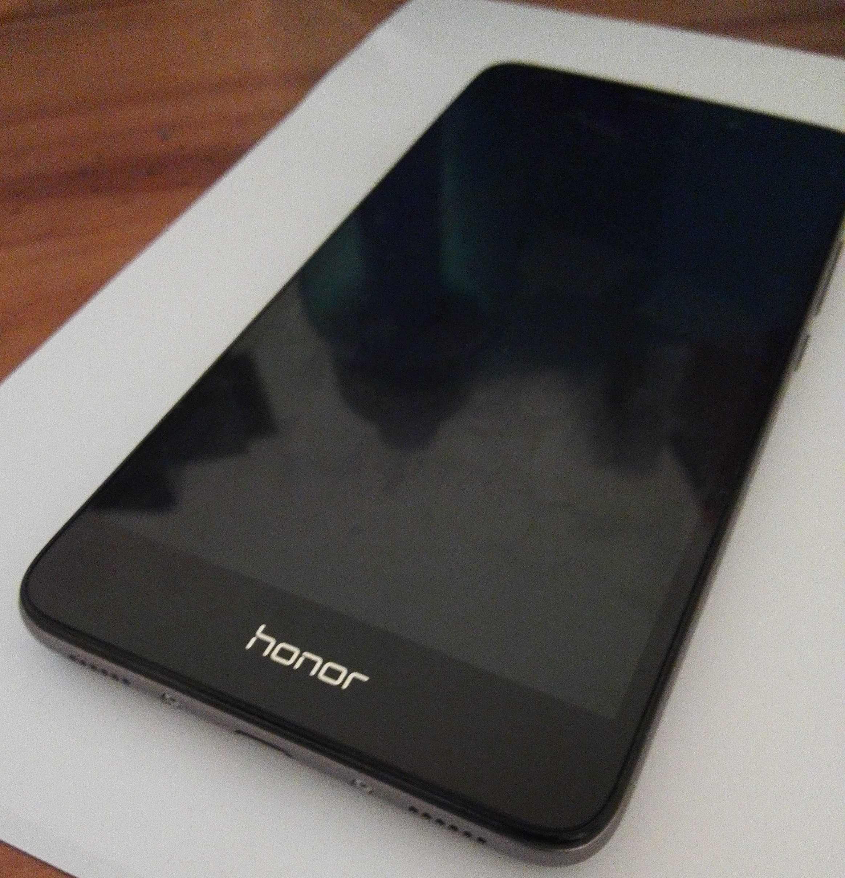
Honor 5C Review

Huawei Honor 5C, also known as the Huawei Honor 7 Lite, is a flagship phone made by Huawei Technologies which was released in May 2016. This phone enters the mid-market sector, retailing at around £150 at the time of writing this review. This phone comes pre-installed with the Android v6.0 operating system, with a screen size of 5.2 inches along with the supporting resolution of 1920x1080 and supports the HSPA/LTE bandwidth. Mobile specifications for this handset include the Kirin 650 chipset having eight octa cores (four cores at 2.0GHz and the other four cores at 1.7GHz), 2GB ram, supports microSD (with supports up to 256GB), 13MP and 2MP front and back cameras respectively. Honor 5C also has a 3.5 millimetre headphone jack located at the top of the headphone, whilst the speakers and the charging port
appear the bottom of the handset. Honor 5C however
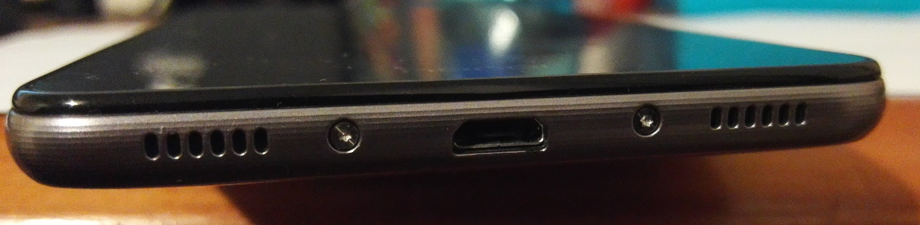
does not support features seen in more premium
smartphones, like the Google Pixel, including
finger-print detection, and fast charging.
However, compared to other phones, such as the Moto G
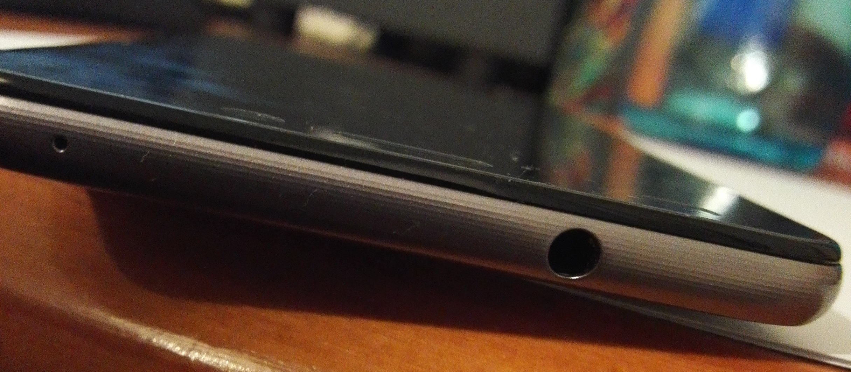
(4th Gen edition), in the price range of the Honor 5C –
the Honor 5C stands out alone based on its
impressive specifications. Honor 5C also has a brushed metal finish which adds to the build quality of the handset.

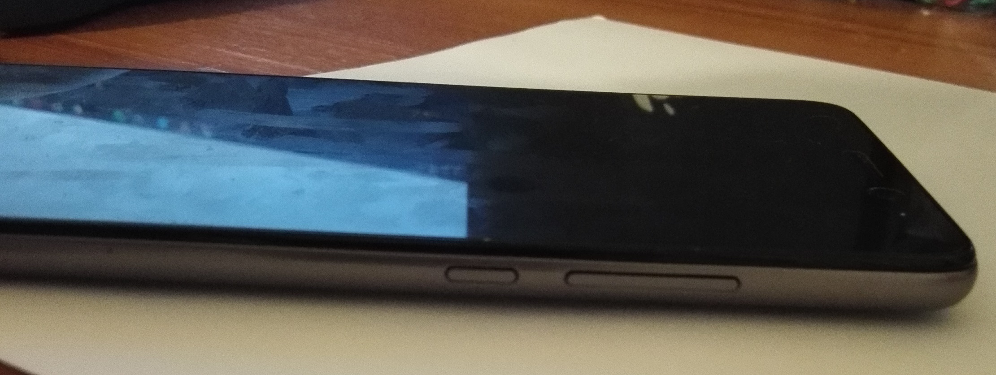
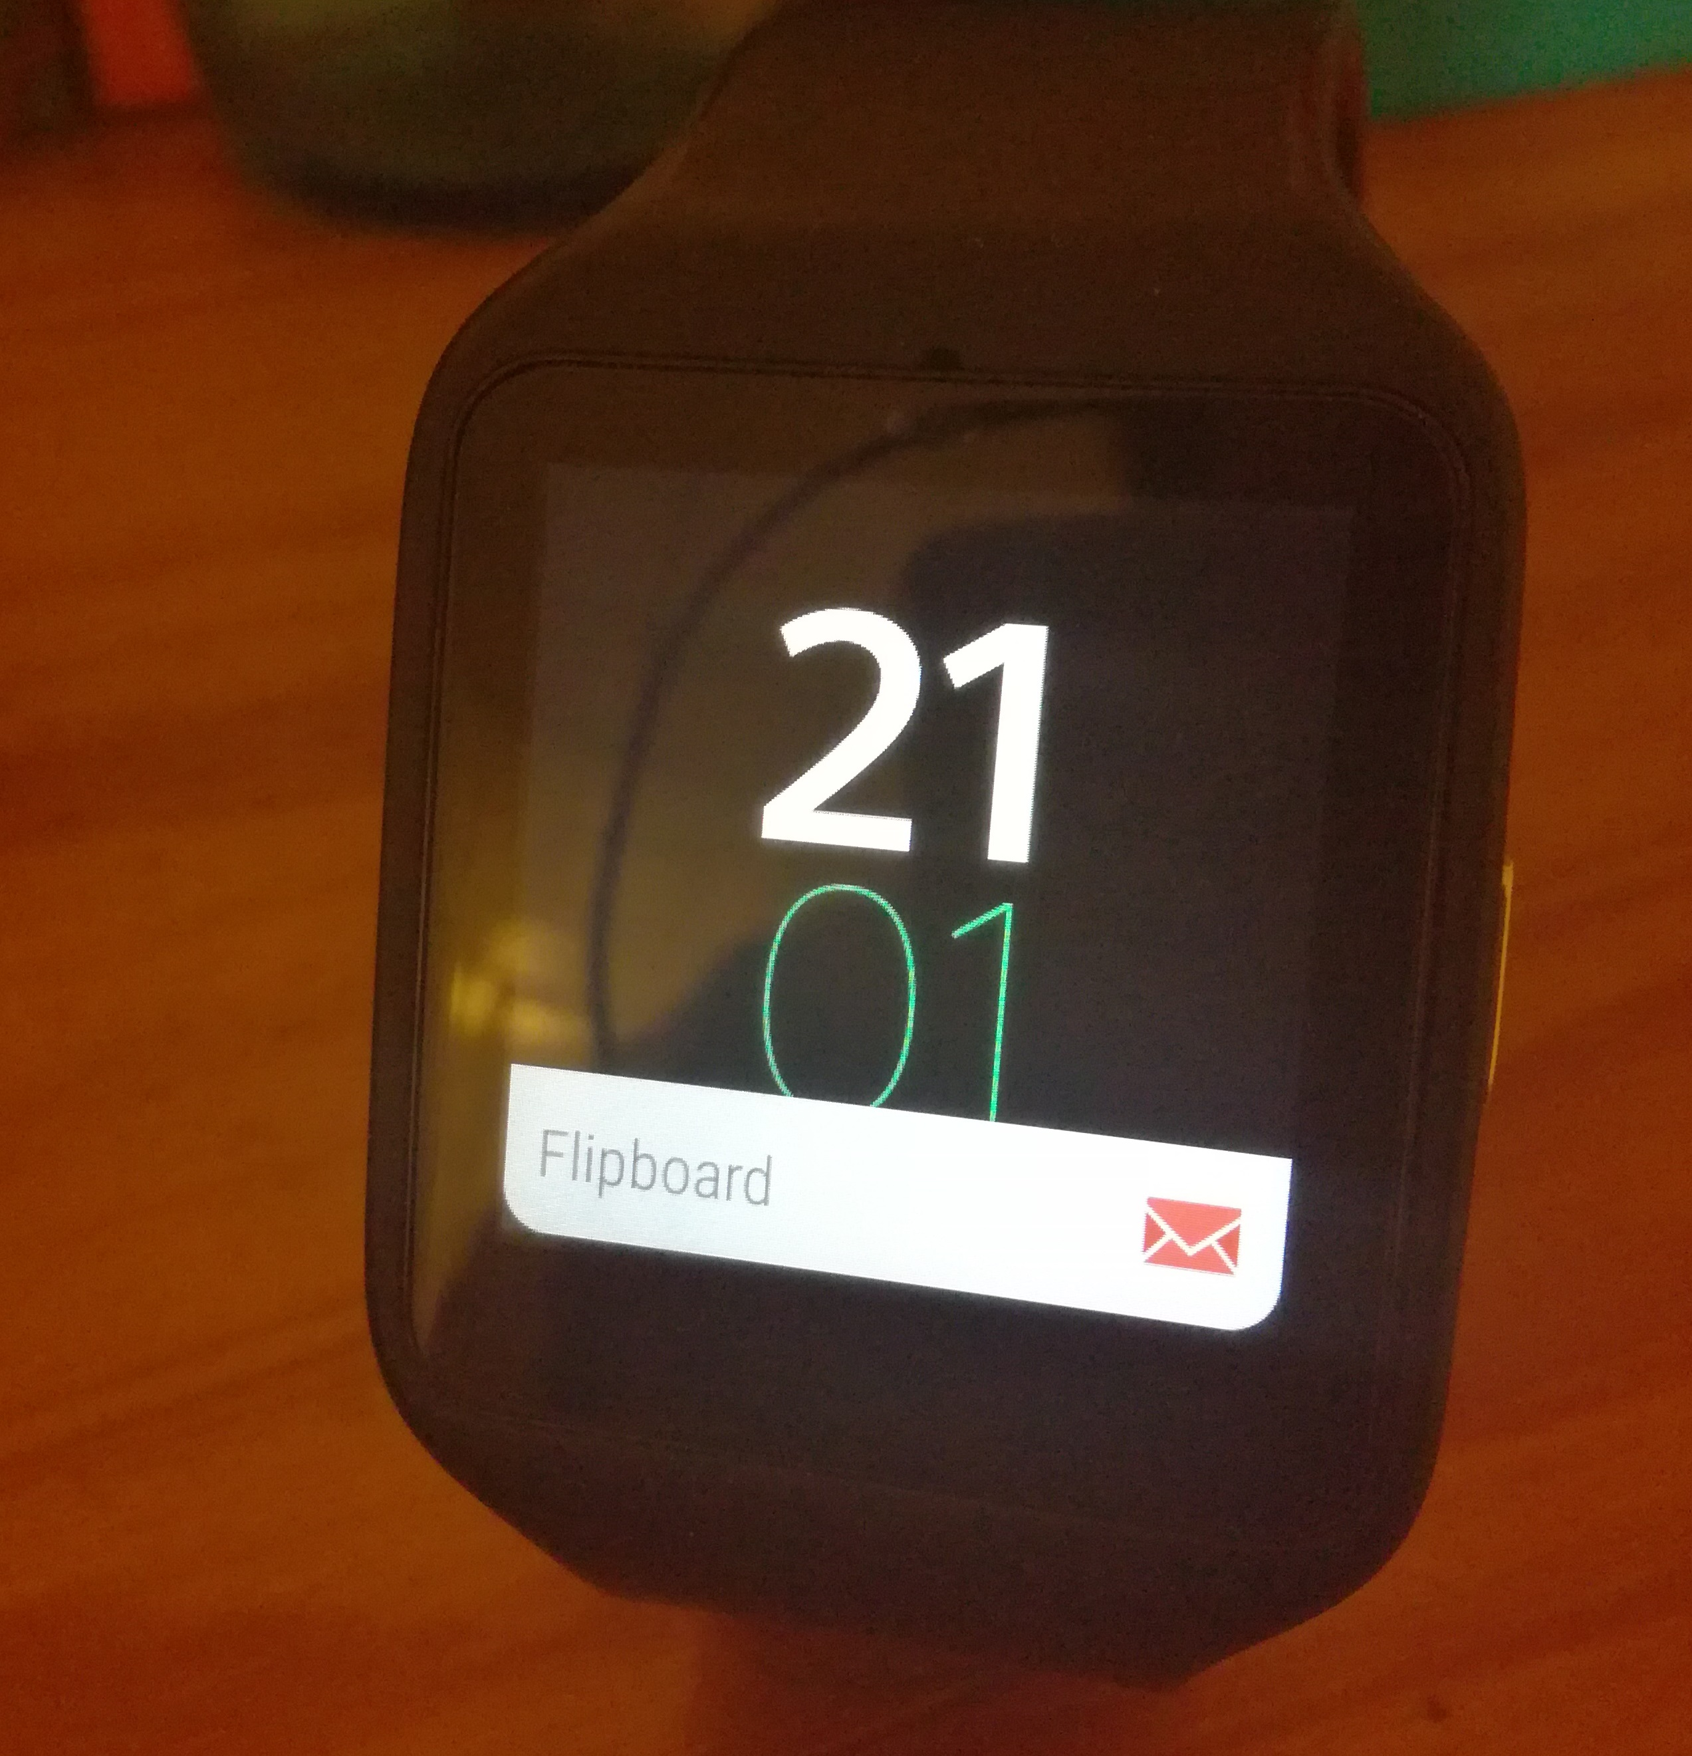
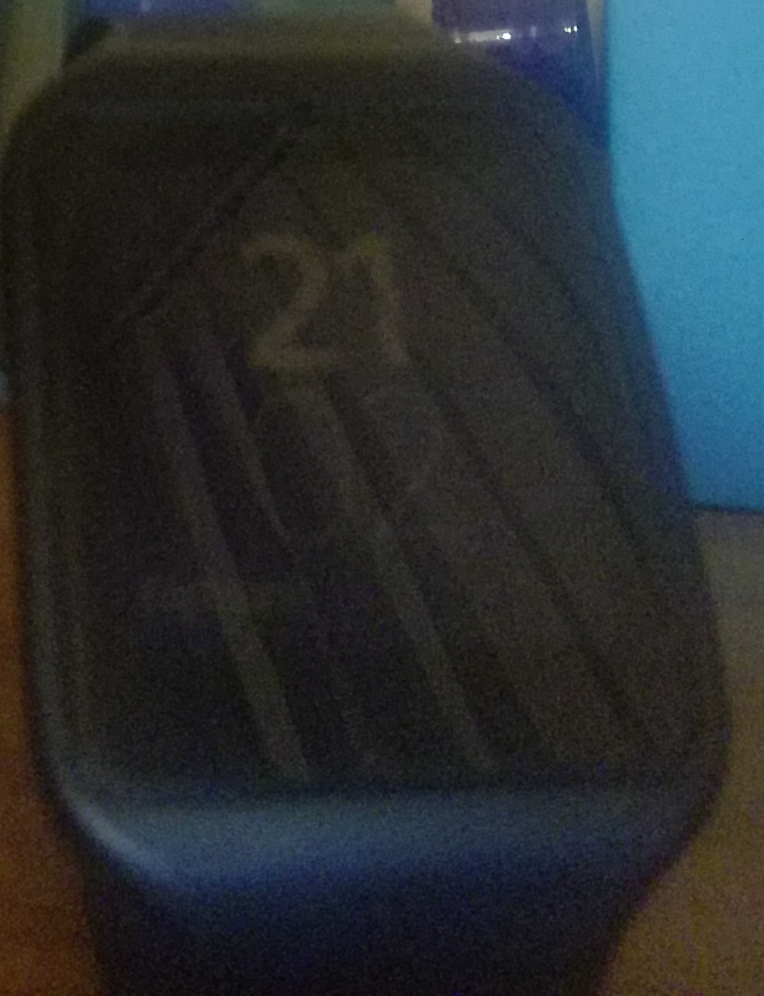
This phone will last around six to eight hours with moderate usage, using the standard performance mode. There are two other features which help with improve battery life including smart and Ultra mode. Smart mode will reduce the performance of the CPU and network usage, whilst Ultra mode will switch off network connectivity, and you will only be able to use the messaging and calling capabilities of the handset. Ultra mode is handy to have if the battery really needs to be saved – and will automatically activate if the battery is below 7%.

Honor 5C which supports the 13MP front and 8MP back cameras, is one of the best contenders for a mid-range phone where taking good quality pictures is desired. One of the best features about the back camera is that macro shots get into focus quite quickly so that crispy images can be taken. However the front camera does not support this feature, and together with the smaller pixel resolution – images taken from the front camera look a little grainy and washed-out.Although Honor 5C does support recording at 1080p, it doesn't have functionality of supporting recording at 4K. As this feature is seen more commonly in mid-range phones, it is disappointing not to see this functionality.
Pictures of the Sony Smartwatch 3 using
the front (13MP) and back (8MP) camera on 'Beauty' mode respectively on the Honor 5C

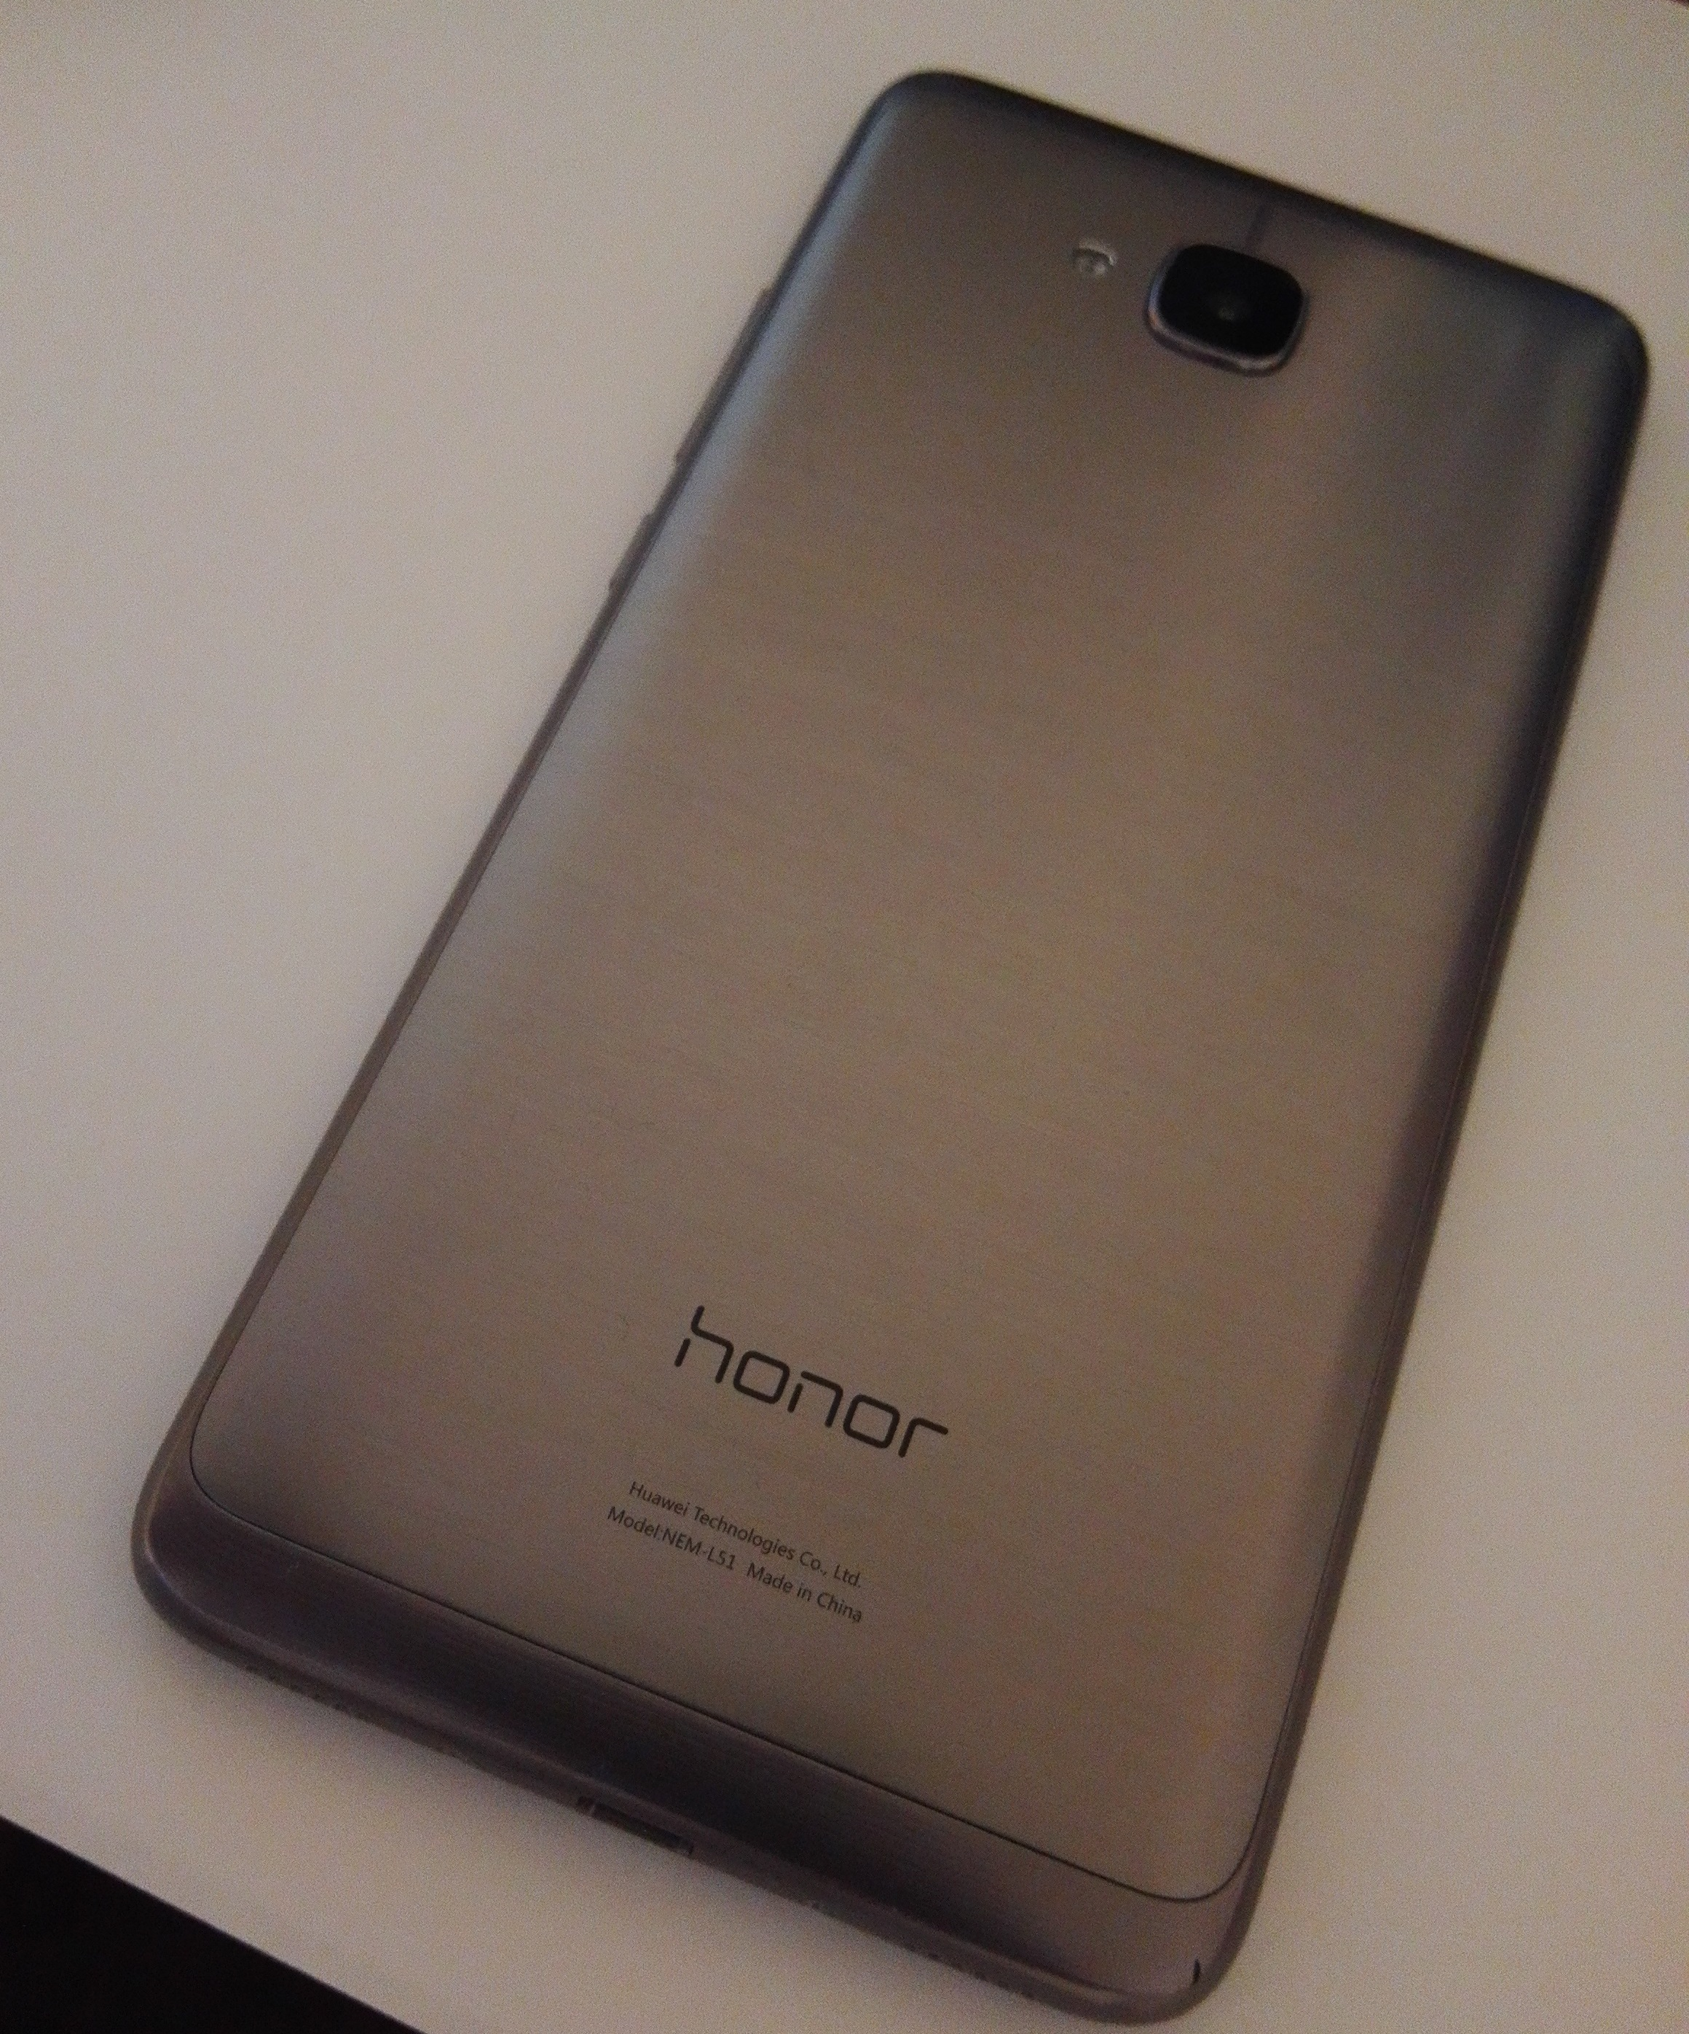
The experience of having used the Honor 5C for a few months has been greatly satisfying. There has been no lag or any kind of slowdown from the device – including when running demanding Android games such as Asphalt 8. It can also handle having multiple applications open at one time easily. Notable disadvantage of this handset is it does not have the newer technologies introduced in smart-phones. Also, has the back of the handset has a brushed metal finish, it is prone to scratches – hence getting a case for this handset is highly recommended.

Overall Rating: 8/10
Performance Rating: 8/10
Battery Life Rating: 8/10
Display Rating: 10/10
Value Rating: 9/10

Honor 5C can be described has 'the phone which offers the benefits that more expensive smart-phones offer and a lower and more affordable cost to the mobile mid-range market'.

Sean-Michael Tulloch

